Executive Summary & Architectural Logic
Traditional signature-based antivirus solutions often fail against zero-day ransomware or custom-compiled data-wiping payloads. To mitigate this threat vector on unmanaged local endpoints, a zero-trust data-integrity model was established utilizing Windows Defender Controlled Folder Access (CFA).
Instead of monitoring process reputations, CFA enforces rigid kernel-level security boundaries around user-defined directories, permitting file modifications only to explicitly whitelisted and trusted binaries.

Phase-by-Phase Technical Implementation
The deployment of this custom hardening strategy was successfully executed via administrative PowerShell commands in three progressive phases:

Phase 1: Global Feature Activation
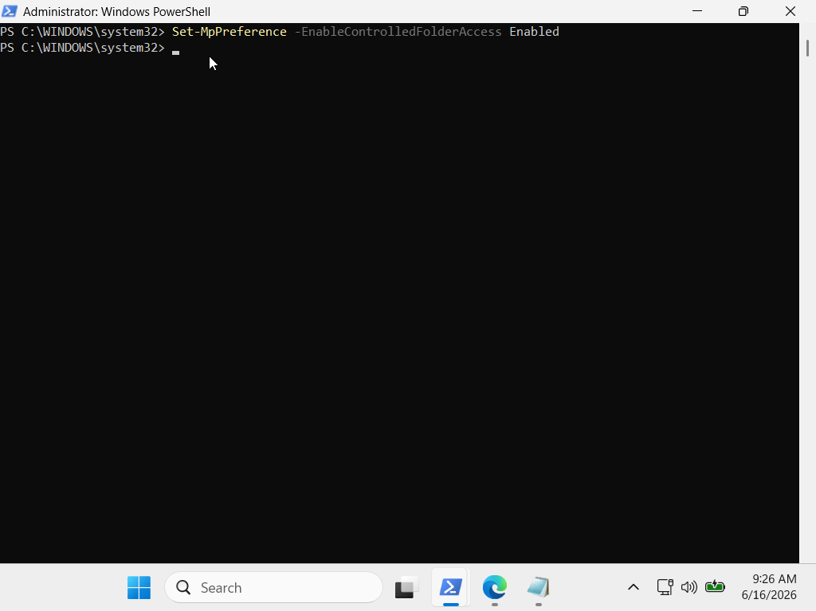
The Controlled Folder Access subsystem was enabled globally on the host operating system. This shifts the Windows Defender engine from passive observation into active behavioral enforcement mode for protected storage zones.

Phase 2: Custom Perimeter Definition (Target Hardening)
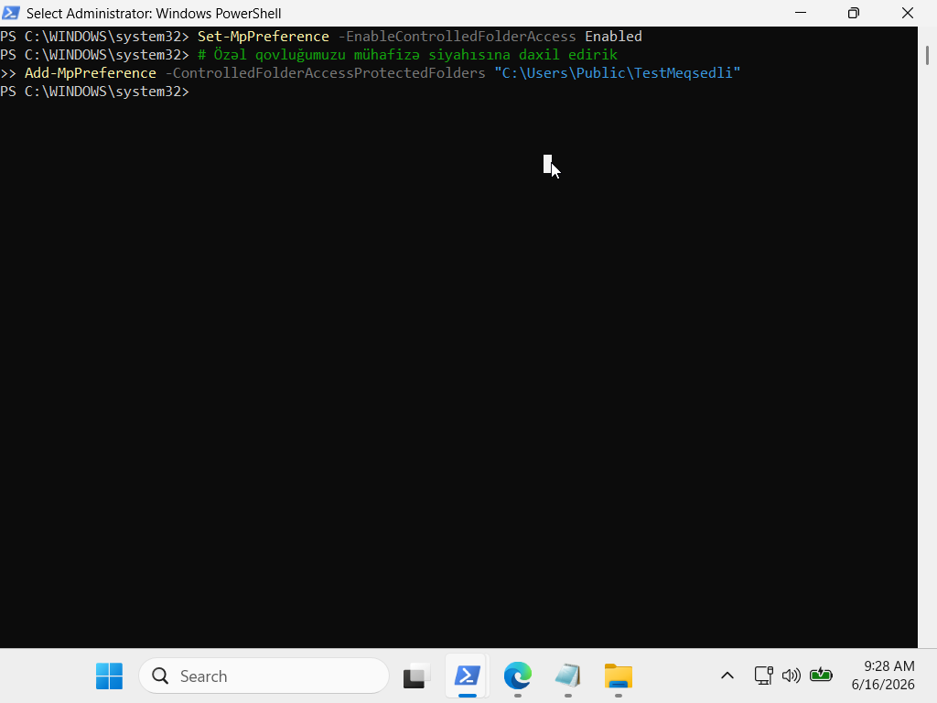
A strictly classified local directory was provisioned and added to the secure enforcement scope. Once registered, the operating system isolates this directory from general user-space application writes.

Phase 3: Least Privilege Whitelisting (Application Isolation)
To establish operational business continuity without loosening security perimeters, a strict Access Control List (ACL) was defined. The native text editor (notepad.exe) was designated as the sole trusted broker authorized to perform Input/Output (I/O) modifications inside the perimeterPhase 3: Least Privilege Whitelisting (Application Isolation)
To establish operational business continuity without loosening security perimeters, a strict Access Control List (ACL) was defined. The native text editor (notepad.exe) was designated as the sole trusted broker authorized to perform Input/Output (I/O) modifications inside the perimeter.
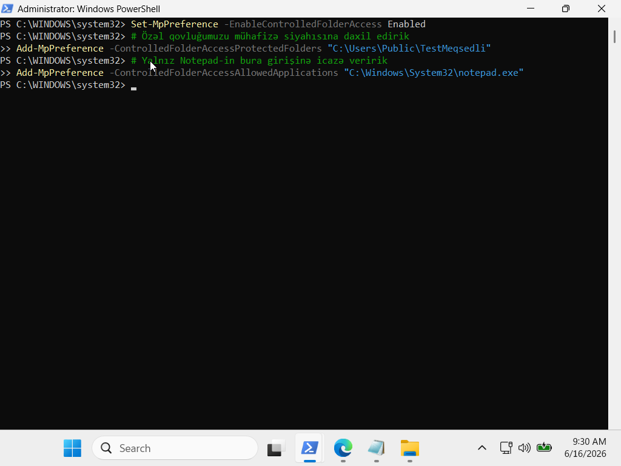

Blue Team Telemetry & Incident Response Logs
Any untrusted binary or malicious payload attempting to modify files within the directory will be instantly blocked at the file-system driver level (wdfilter.sys). Blue Team analysts can audit and monitor these block actions within the Windows Event Viewer under the following path:
- Log Channel: Applications and Services Logs \ Microsoft \ Windows \ Windows Defender \ Operational
- Event ID: 1123 (CFA Block Event)
The structured telemetry event automatically captures the unauthorized process name, the targeted file path, and the user context, enabling immediate triggering of automated incident response playbooks.

